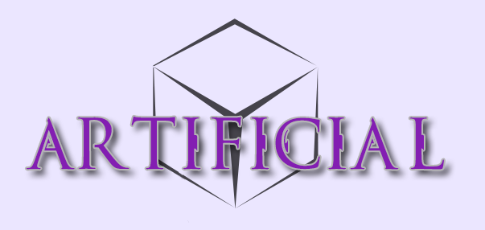

Art Bible

**Table of Contents**

Style

Themes

Technical

Tilesets/Map

Weapons and Items

Color

Player Hub Spaceship

Zone 1 - Vardus

Zone 2 - Teriss

Zone 3 - Ilnus

Characters/Sprites

UI Design

Normal

Rare

Very Rare

# 

# Style

Artificial’s art style will be a pixel style. Objects and entities within the world will be a more solid edged pixel design, with an almost cell-shaded style.  
The backgrounds will have a more textured-painted look than objects that are part of the foreground. This will help distinguish objects that are interactive for the player.

## Shading

The shading will be done with dilation. Highlights will only be straight lines and not dilation.

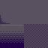

# Themes

The game will have a heavy theme on biotechnology style objects and landscapes. This includes the flora and fauna of each biome. With enemies and neutral planet life having elements of technology imprinted on them. This can be in sci-fi looking armours or simply designs and patterns on the skin or surface of the creature/object. A lot of things will have glowing parts and implanted technology (cyborg).

# Technical

*All art that will used in the game must be saved as png file format.*

### Tilesets/Map

There will be multiple tilesets for each area. These tilesets can/may include:

1. **Background Tileset** - This tileset will include all of the walls and floors that will make up the furthest back layer of each map/room.
2. **Features Tileset** - This tileset will consist of features that can be used to give the map/room variation over the normal tiles. Including grass, rocks, vines, and other non-interactable features. 520x520 filesize, with 64x64 tiles, 1 pixel between each tile.
3. **Animation Tiles** - These tiles will be created as animation strips. These will include any background objects that must be animated but are non-interactive, such as waterfalls, blowing sand etc. They can be any size necessary to fit the frames of animation with a maximum width of 256px.

### Weapons and Items

**Weapons -** The weapon sprites will all be a maximum size of 192x64.

**Shields -**  All shields will be 64x64 sprites.

# Color

The colors of each area will be distinct and help to give the player a sense of progression. With each new area bringing a new theme and set of colors.

## Player Hub Spaceship

The central player hub will have a lot of grey colors with orange decals and text on the walls. Everything on the ship will look high tech and have a cold grey feeling. There will be a lot of red lighting to darken the mood on the player ship. Giving the player a feeling that something is not quite right here. The area around the cube on the ship will be the lightest, indicating the importance of the cube.

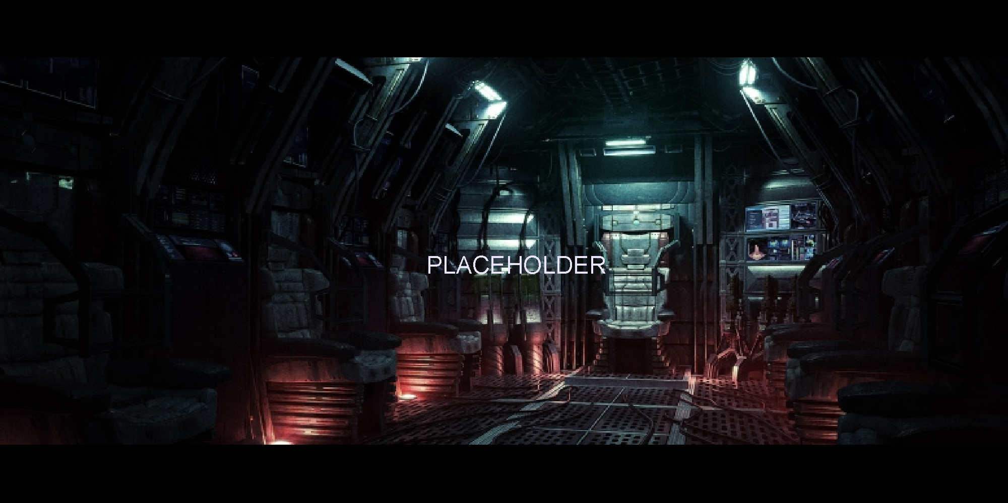

## Zone 1 - Vardus

The color palette for the first zone will be mostly oranges, reds, browns, and pinks. Objects that populate the first area, including flora and fauna will be tinted more blue and green colour to balance the colors on the first area. The design will be square blocky style rocks and features.

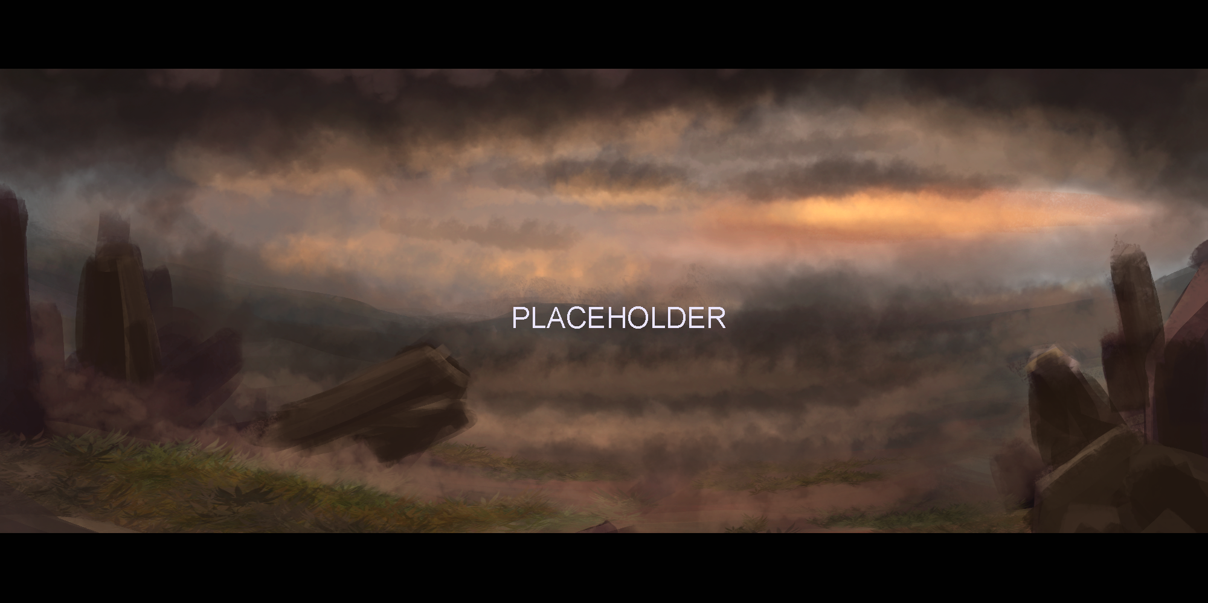

## Zone 2 - Teriss

Teriss, being a snow zonet, will have dark grey rocks, and light blues with a mostly white palette for the tileset colors. The landscape will have icey spike-like features. Objects and plants will be an dark cold blue. Areas that have water will have lush green plant life mixed in with the cold feeling of the snow and ice.

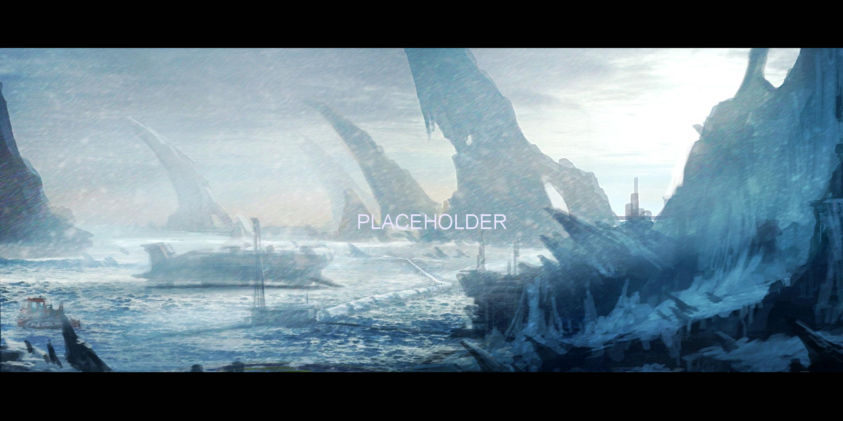

## Zone 3 - Ilnus

This Biome will be a poisonous themed area. The colours will be less saturated than previous zones. Consisting of purples, orangey-red, and muted green colours. The enemies and objects that can hurt/interact with the player will be more saturated to help them stand out from the backgrounds. The poisonous spell effects will also be more saturated.

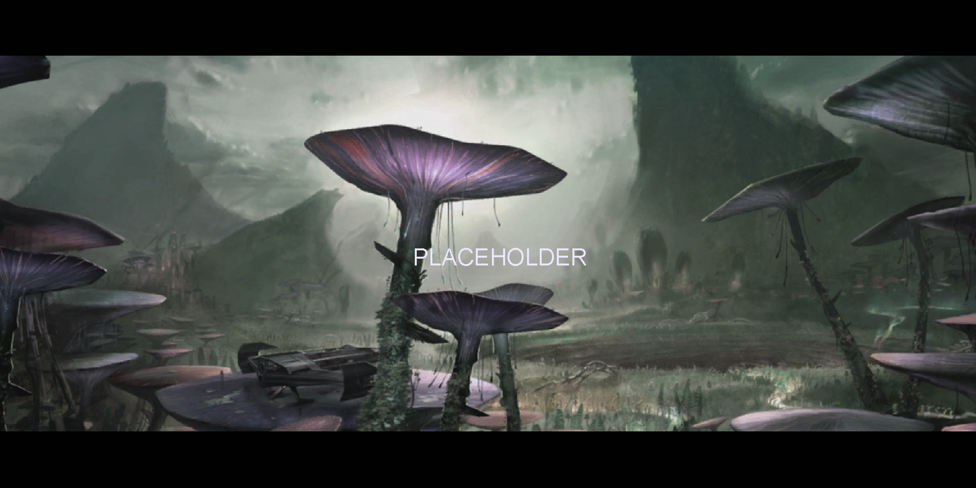

# Characters/Sprites

The characters and enemies in the game will all be medium resolution pixel art. (64w x 128h)

Each sprite will have its own palette with no limit on the number of colors, however, they should be made to look as if they are 16 bit color schemes, even though they are not.

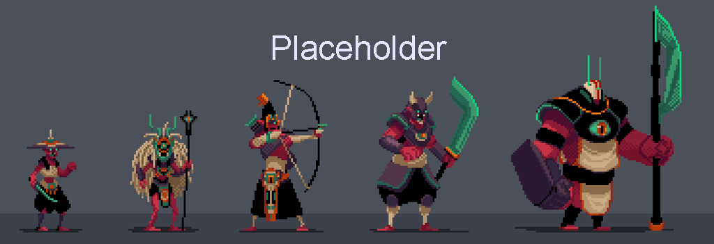

Any objects that need to be animated will be saved as animation strips with a maximum width of 512px. (8 frames per row)

Some of the larger enemies will be up to a maximum of 128px wide.

# UI Design

The User Interface will have a very sleek modern design. With most GUI elements being solid rectangles. The colour scheme for the GUI will be Dark-Grey Gradient and different colour headers depending on the UI element. The UI will be overlayed with a slight transparency. The headers on certain UI elements will indicate the rarity or value of an item.

### Normal

### Rare

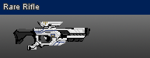

### Very Rare

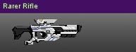

Playable space unplayable space*